# confluence安装文档

系统ubuntu14.04

## 一、安装MySQL

### 1、安装

apt-get install mysql-server mysql-client

### 2、添加两个选项

vim /etc/my.cnf

character_set_server = utf8

transaction-isolation=READ-COMMITTED

### 3、配置密码

mysqladmin –uroot password ‘gathink’

### 4、创建数据库

mysql –uroot –p

CREATE DATABASE IF NOT EXISTS confluence DEFAULT CHARSET utf8 COLLATE utf8_bin;

### 二、安装jdk1.8

1、安装

tar xf jdk-8u151-linux-x64.tar.gz

mv jdk-8u151-linux-x64 /usr/local/java

2、添加Java环境变量

vim /etc/profile

export JAVA_HOME=/usr/local/java

export CLASSPATH=$JAVA_HOME/lib/

export PATH=$PATH:$JAVA_HOME/bin

## 三、下载并安装confluence

执行./ atlassian-confluence-6.5.0-x64.bin

按指令选择选项

## 四、安装

### 1、破解文件

 mysql连接文件

 破解文件1

 破解文件2

### 2、替换俩个文件，分别是

/opt/atlassian/confluence/confluence/WEB-INF/lib/atlassian-extras-decoder-v2-3.2.jar

/opt/atlassian/confluence/confluence/WEB-INF/atlassian-bundled-plugins/atlassian-universal-plugin-manager-plugin-2.22.jar

添加文件

/opt/atlassian/confluence/confluence/WEB-INF/lib/mysql-connector-java-5.1.44-bin.jar

### 3、重启Confluence服务

/opt/atlassian/confluence/bin/catalina.sh stop

/opt/atlassian/confluence/bin/catalina.sh start

netstat -anpt | grep 8090 查看端口

### 4、访问confluence继续安装

http://192.168.240.200:8090

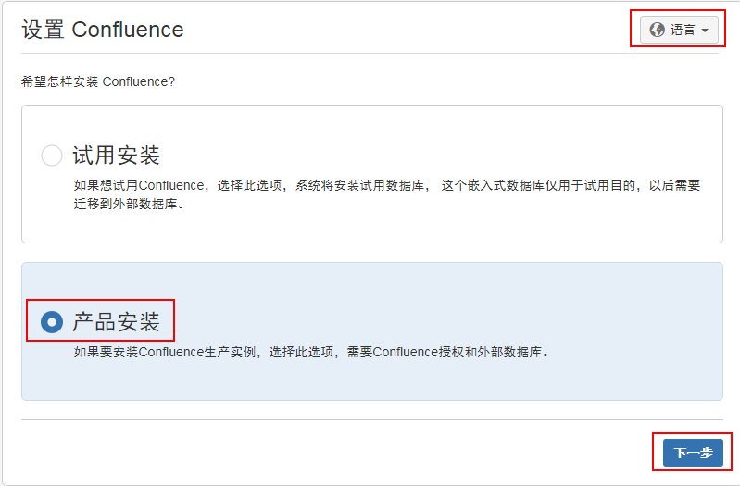

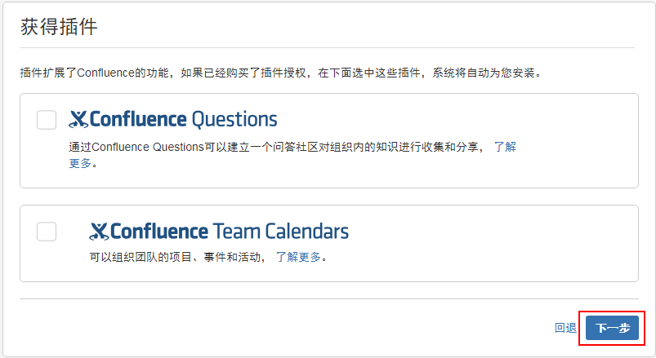

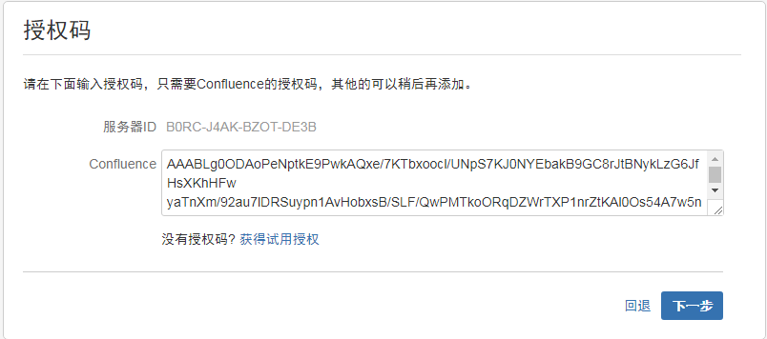

获取试用授权要有一个atlassian的账号，用邮箱注册一个即可

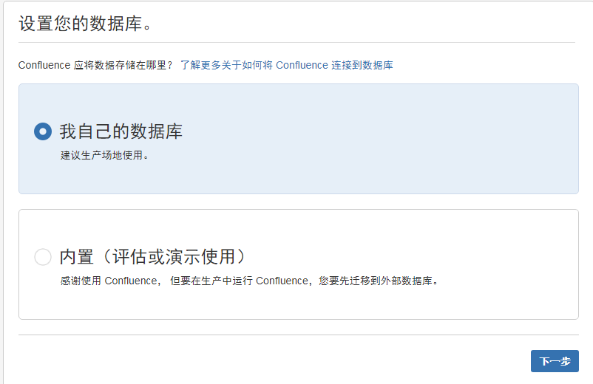

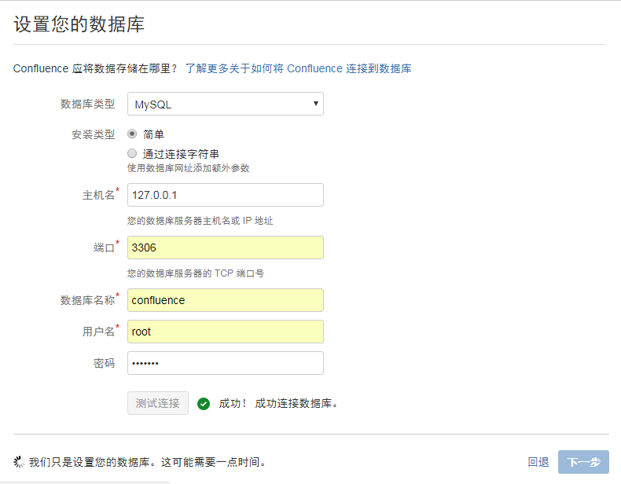

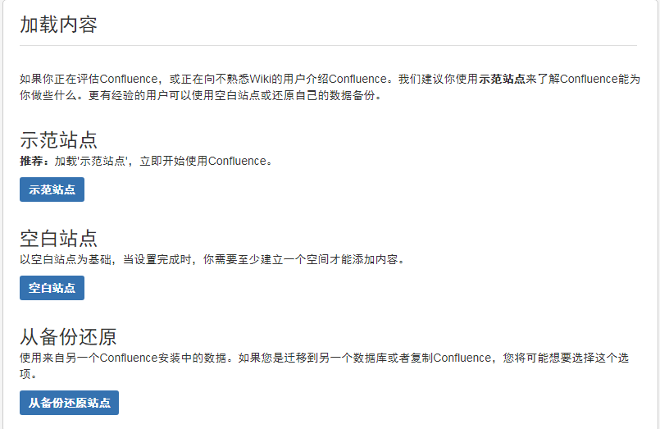

用户可以使用jira 的安装过程中选择即可

优化：

1、附件中文显示调整：

apt-get install fonts-arphic-ukai fonts-arphic-uming ttf-mscorefonts-installer

将windows中的微软字体拷贝到/opt/atlassian/confluence/jre/lib/fonts/fallback

2、修改tomcat的最大内存

vim /opt/atlassian/jira/conf/setenv.sh

CATALINA_OPTS="-Xms8192m -Xmx16384m -XX:+UseG1GC ${CATALINA_OPTS}"

CATALINA_OPTS="-Dconfluence.document.conversion.fontpath=/opt/atlassian/confluence/jre/lib/fonts/fallback ${CATALINA_OPTS}"

3、调整下面的数值：

vim /var/atlassian/application-data/confluence/confluence.cfg.xml

<property name="confluence.setup.locale">zh_CN</property>

<property name="confluence.setup.server.id">BTB3-C12D-WF24-31FO</property>

<property name="confluence.webapp.context.path"></property>

<property name="hibernate.c3p0.acquire_increment">10</property>

<property name="hibernate.c3p0.idle_test_period">100</property>

<property name="hibernate.c3p0.max_size">60</property>

<property name="hibernate.c3p0.max_statements">100</property>

<property name="hibernate.c3p0.min_size">20</property>

<property name="hibernate.c3p0.preferredTestQuery">select 1</property>

<property name="hibernate.c3p0.timeout">120</property>

<property name="hibernate.connection.driver_class">com.mysql.jdbc.Driver</property>

<property name="hibernate.connection.isolation">2</property>

nginx安装

server {

listen 80;

server_name wiki.gnetis.com;

access_log /var/log/nginx/access.log;

error_log /var/log/nginx/error.log;

#root html;

index index.html index.htm index.php index.jsp index.jspa Dshboard.jspa;

port_in_redirect off;

location ~* ^.+/.(jpg|jpeg|gif|png|swf|rar|zip|css|js)$ { ##static file

rewrite ^(.*) http://wiki.gnetis.com:8090/$1;

break;

}

location / {

proxy_pass http://127.0.0.1:8090;

proxy_redirect off;

proxy_set_header Host $host:$server_port; ##重点在$server_port

proxy_set_header X-Real-IP $remote_addr;

proxy_set_header X-Forwarded-For $proxy_add_x_forwarded_for;

proxy_max_temp_file_size 500M;

# proxy_connect_timeout 90;

# proxy_send_timeout 90;

# proxy_read_timeout 90;

# proxy_buffer_size 4k;

# proxy_buffers 4 32k;

# proxy_busy_buffers_size 64k;

proxy_hide_header Vary;

proxy_set_header Accept-Encoding '';

proxy_set_header Referer $http_referer;

proxy_set_header Cookie $http_cookie;

client_max_body_size 500M;

client_body_buffer_size 256k;

client_body_temp_path /etc/nginx/proxy_temp;

}

}